Design Lab Report:

Russell’s Sustainable Investment Structural ESG Score and Company Performance Analysis

Team Member:

Xiaye Xu

Jingxue Feng

Xinjie Guo

Minghan Wang

Date: 8/02/2018

**2. Methodologies**

**2.1 Data Overview**

FTSE Russell Quantitative & Structural Data contains updated Environment, Social and Governance rating. With access to FTSE and Bloomberg historical data and analysis platform, we are able to obtain data needed for this study. The ESG dataset contains three scores: Environmental, Social and Governance (ESG). The range of each score is from 0 to 5 with 0 being no exposure and 5 being the best practice in the area. This dataset captures over 300 indicators, 14 themes and 3 pillars. It also contains ESG score for 10 industries and over 2000 companies. Their green revenue model incorporates 8 key measurements: energy generation,energer equipment, energy management, energy efficiency, environmental infrastructure, environmental resources, modal shift and operation shifts. There are multiple subcategories in each of the measurements. For more information on ESG score methodology, please refer to FTSE Russell official report via link: [**http://www.ftse.com/products/downloads/FTSE_ESG_Index_Series_Ground_Rules.pdf?912**](http://www.ftse.com/products/downloads/FTSE_ESG_Index_Series_Ground_Rules.pdf?912)

We analyze the dataset in two aspect: descriptive and predictive. The descriptive analysis studies the most recent data (march 2018). We present the descriptive analysis in 4 aspect: country level, industry level, market capitalization and distribution of each score in 2018. The predictive section studies historical data from september 2014 to march 2018. The historical data demonstrate the trend in different aspects. The purpose of predictive analytics is to analyze the correlation between E,S,G score and company performance variables. All the company performance data is downloaded from bloomberg terminal using excel bloomberg add-in function.

|  |
| --- |
| **Data Sources**  FTSE Russell Quantitative & Structural Data  Bloomberg |
| **Data Preparation**  Missing value  Combine differing historical document  Combine company’s historical performance |
| **Analytics Platform/Tools Selection**  Tableau, Python, R. Excel |
| **Analytics Implementation**  Analyze and visualize current market; give recommendation on investing based on the correlation between ESG score and financial performance |

**3. Descriptive Analysis**

To better understand the green revenue model, we conduct study for E, S, and G score from 3 aspects: country, industry, and market capitalization. This section also includes variable selection and historical trend analysis.

**3.1 Variable Selection**

|  |
| --- |
| **Dependent Variable**  Company Name  Country Name  Date  Industry Classification Benchmark (ICB) Sector  Industry Classification Benchmark (ICB) Industry  **Independent Variable**  **Environmental Score**: Biodiversity, climate change, pollution & resources, water use  **Social Score**: Labor standards, human rights & community, health & safety, customer responsibility  **Governance Score:** Tax transparency, risk management, corporate governance, anti-corruption  **ESG Score:** Average of environmental, social and governance score |

**3.2 Country Level Study**

**3.2.1 Country and ESG score**

Figure 3.2.1 shows the number of companies with ESG score by country. The x-axis shows the number of the companies in an descending order and y-axis shows the top 30 countries with highest number of companies. According to this histogram, United States, Japan and United Kingdom have the highest number of companies with ESG score.

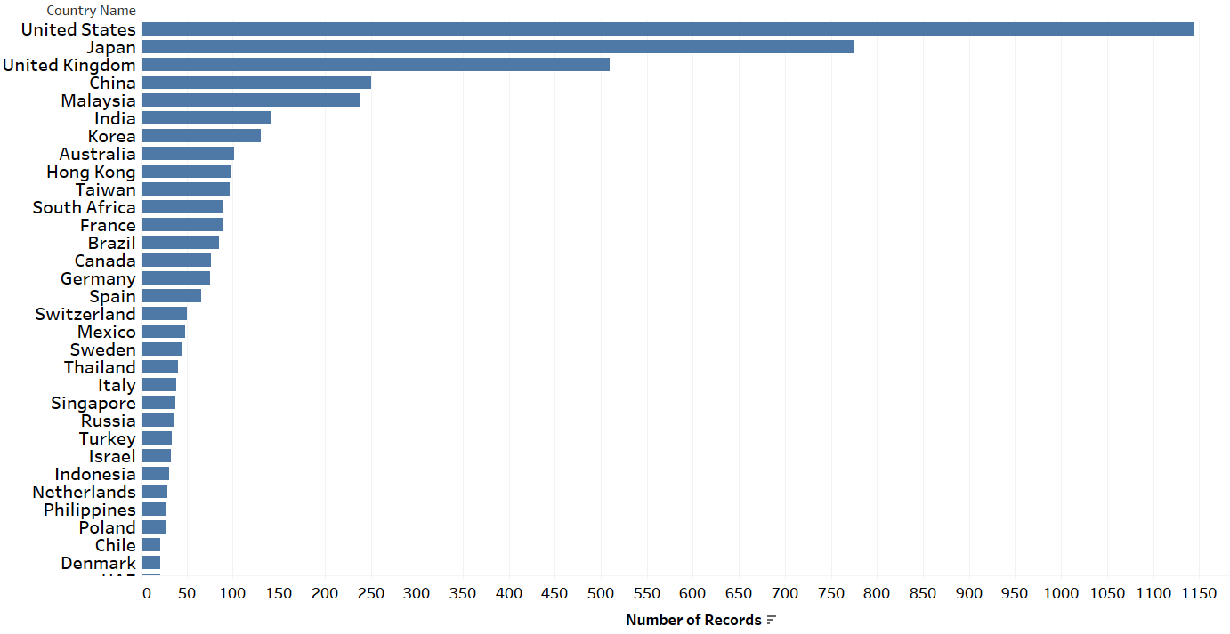

Figure 3.2.1. Number of Companies with ESG score for Each Country

Figure 3.2.2 illustrates the average ESG score for each country in the dataset, with marks identifying country name and its respective average ESG score. The dataset includes companies operating in 60 countries and areas. Countries with higher average ESG score generally yield better result of managing the ESG issues. Top 3 countries with highest scores are: Portugal, Finland, and France, according to the map. Another takeaway from this map is that Europe as a region has the highest density of countries with high average ESG score.

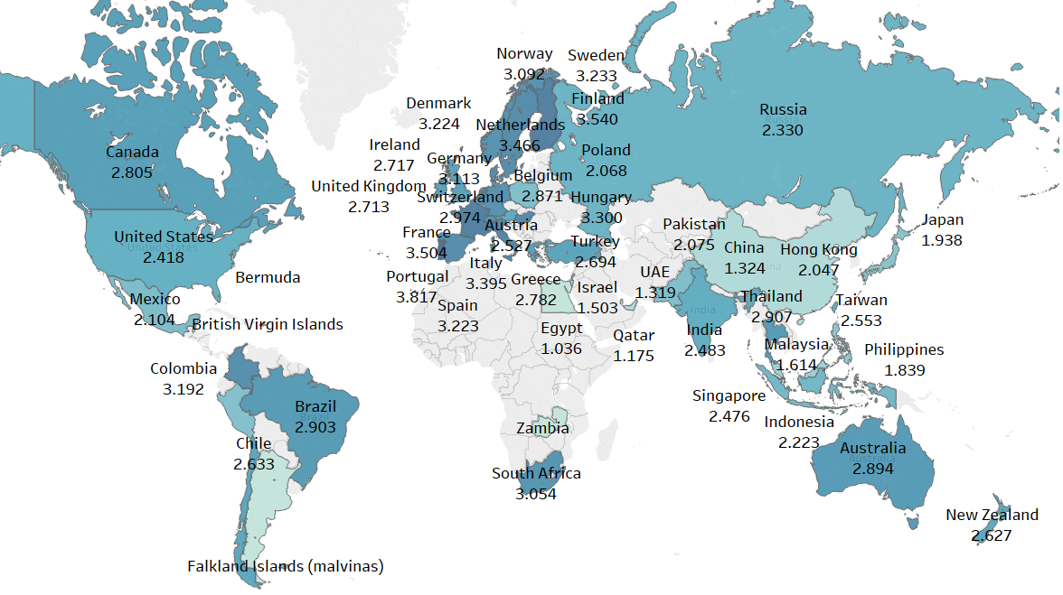

Figure 3.2.2. Country Average ESG score

**3.3 Industry Level Study**

**3.3.1 ESG Score and Industry**

According to the official Industry Classification Benchmark, companies are categorized into ten different industries. The following pie chart shows the distribution of the company industries in our dataset. 54% of the companies in the dataset are in industrials, financials and consumer services industry. Telecommunication industry has the least companies in the list. The chart shows the percentage of companies in each ICB industries. To be exact, there are 2341 companies in financials industry and 2057 companies in industrials industry

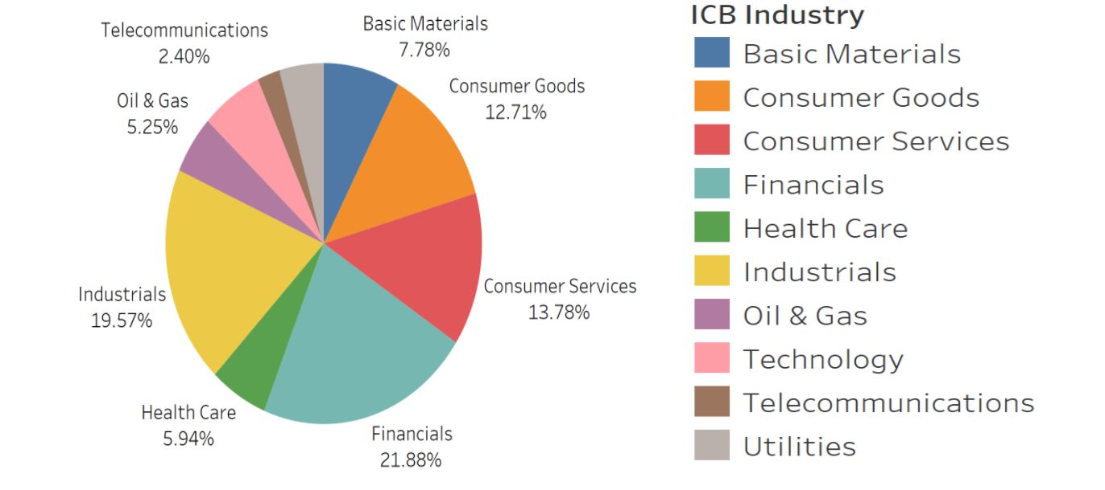Figure 3.3.1.1 Percentage of Companies for Each Industry

The chart below shows the three different average ESG score for each ICB industry. From this histogram, we can compare the difference in the three scores within each industry. Taking consumer service industry for example, we find out that this industry focus heavily on governance aspect but perform poorly on the other two aspect.

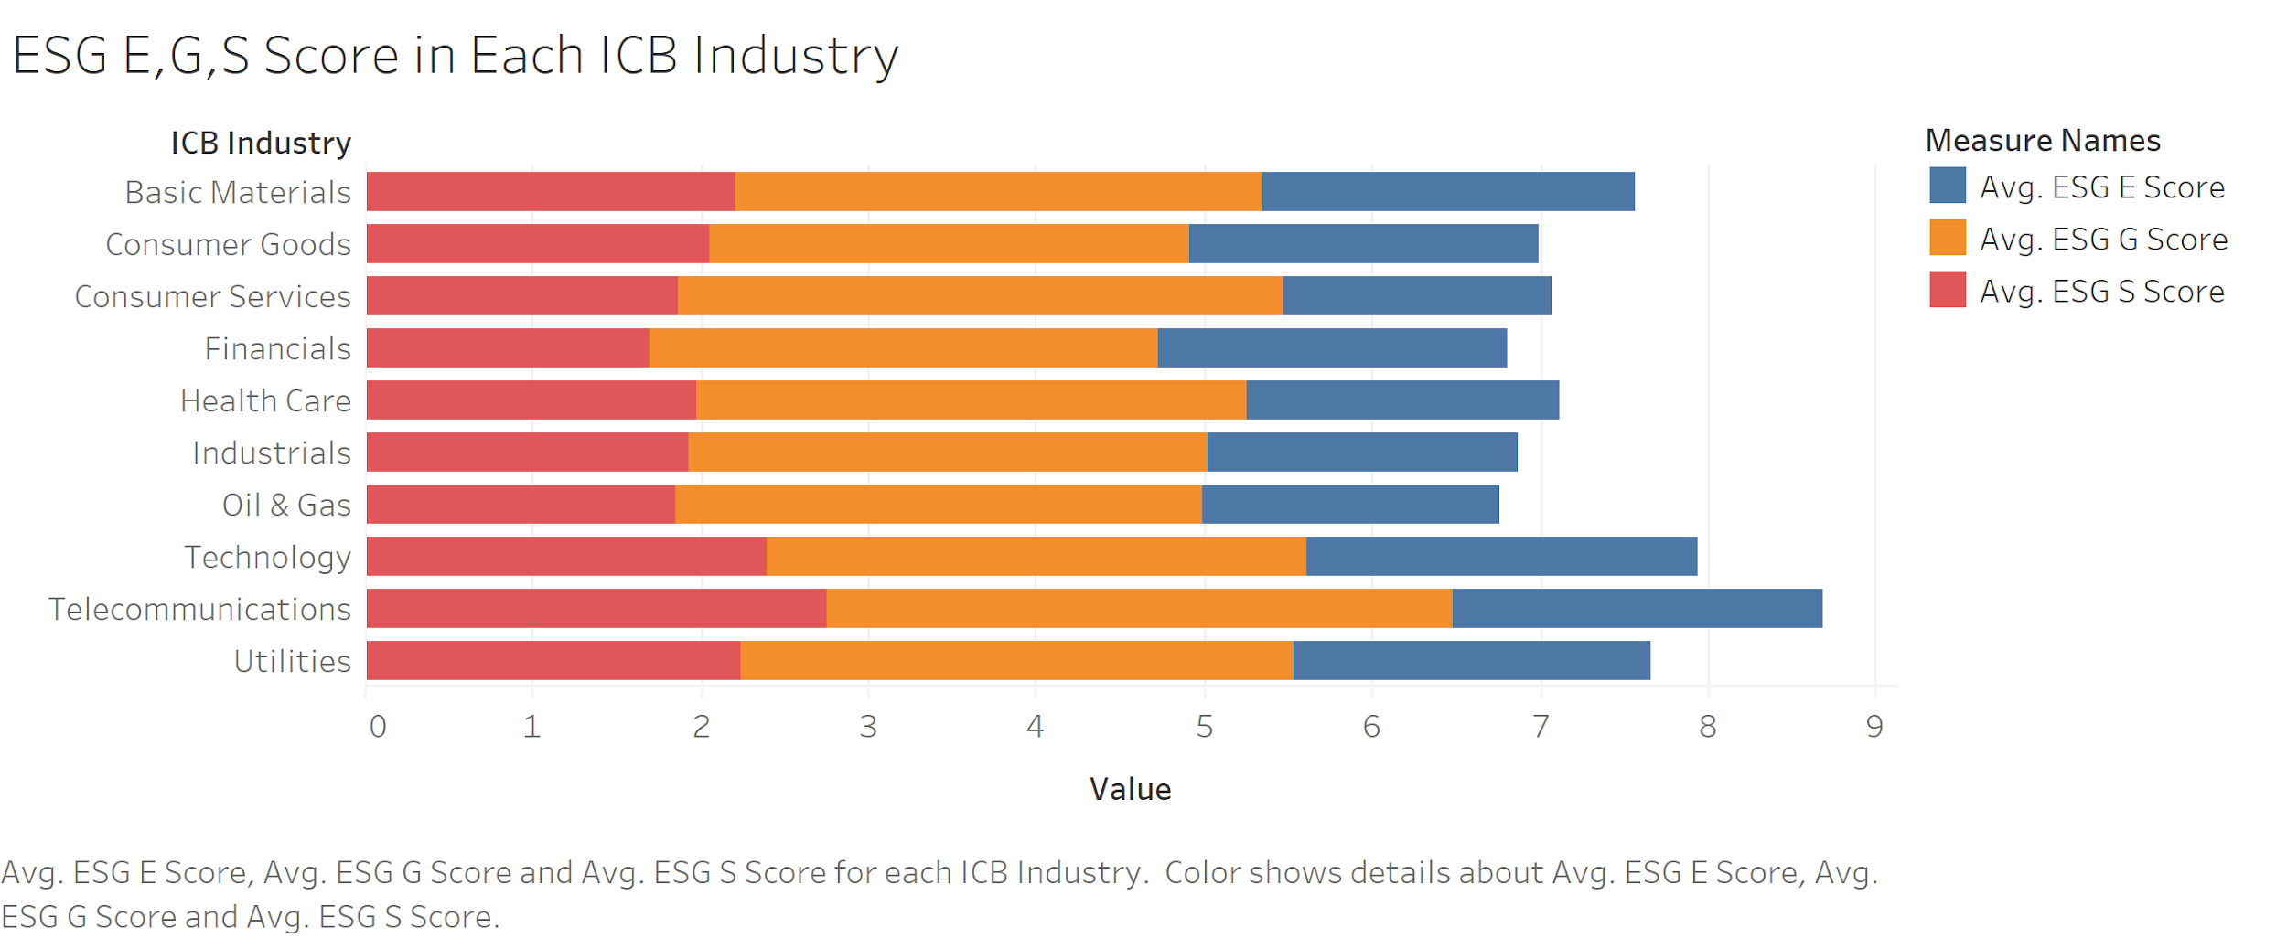

Figure 3.3.1.2 Across Industry ESG Score Histogram

We believe that in addition to the difference in industry distribution, each of the E,S and G scores also fluctuates across different industries. Figure 3.3.1.3 is visualized trend to support this argument. We notice that telecommunication industry has highest average ESG rating, G rating and S rating. It ranks among highest ESG E rating as well. In contrast, Oil & Gas industry is notorious for its destruction to the environment and this is proven in trendline as well.

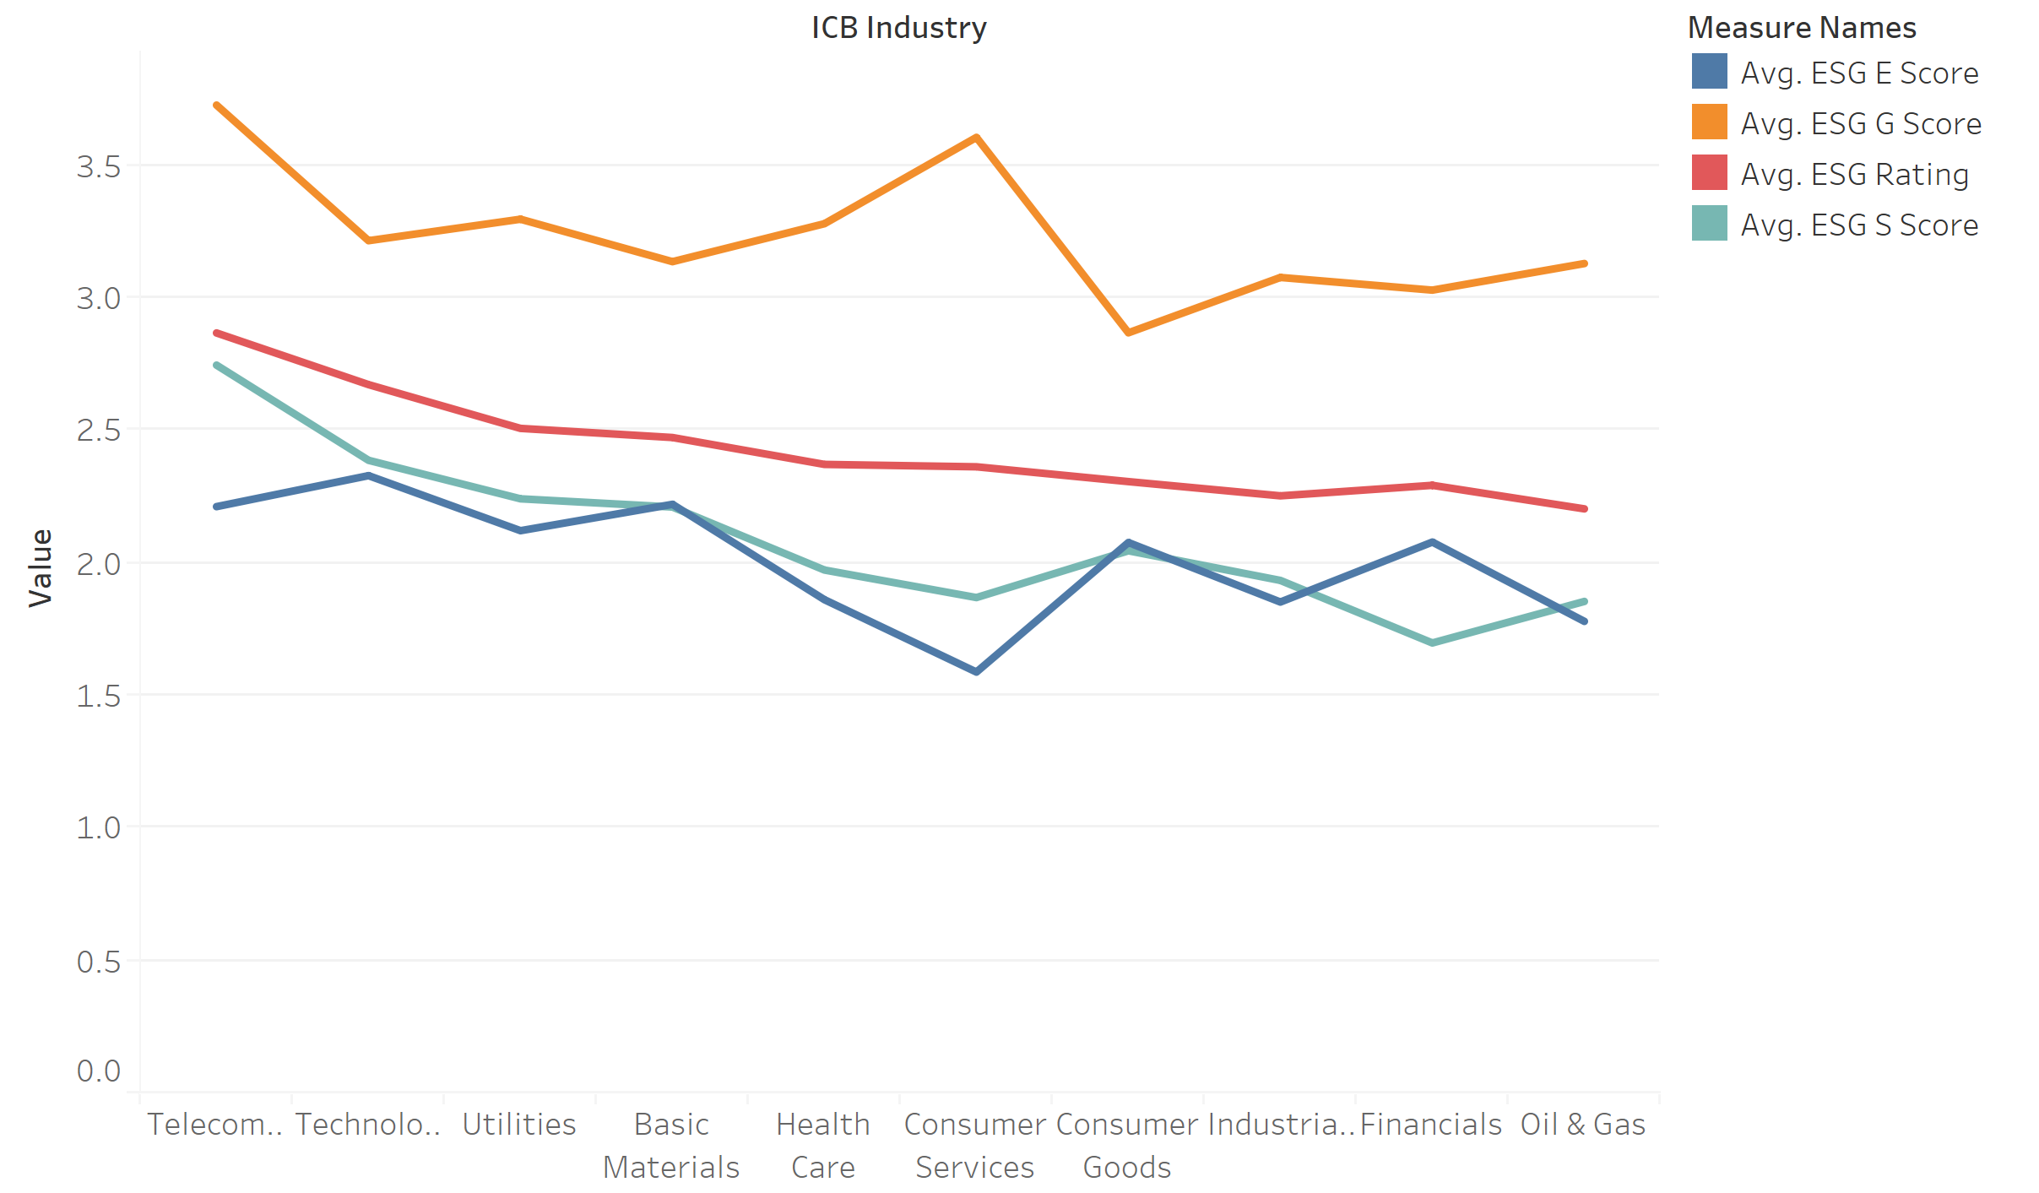

Figure 3.3.1.3 Across Industry ESG Scores Trendline

**3.3.2 E, S and G Score Historical Industry Trendline**

The ESG score for the 10 industries are showing different patterns from December 2015 to December 2017. Figure 3.3.2.1 shows the environment score trend. While health care, telecommunications, and Oil & Gas industries are showing a significant decrease in 2016, scores for other industries are gradually increasing. Since environmental score measures company’s social responsibility on managing the harm to environment, the significant drop in those industries indicate the decline in their environmental responsibilities.

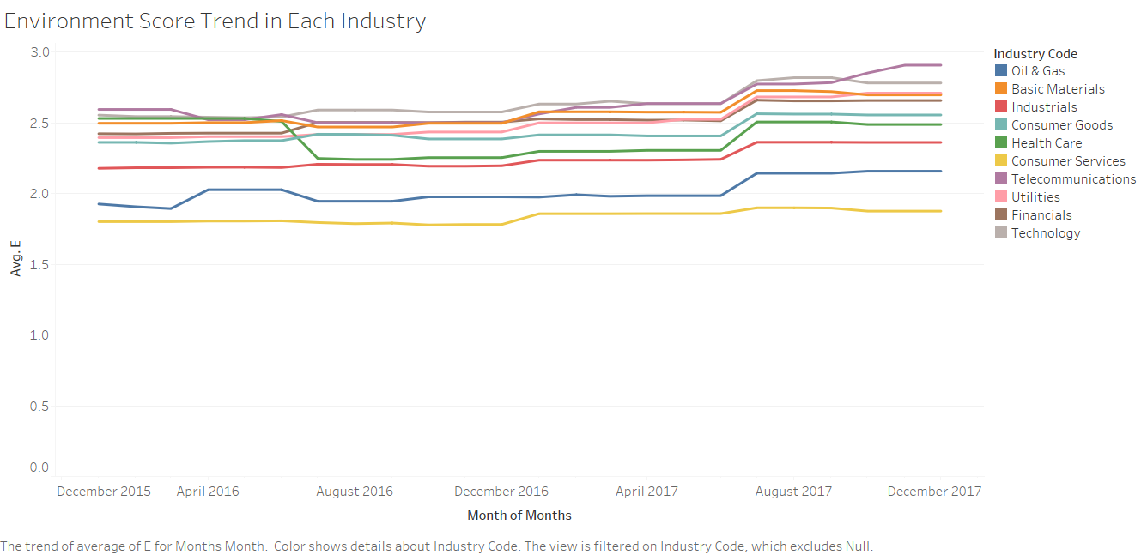

Figure 3.3.2.1 Environment Score Trend in Each Industry

From December 2015 to December 2017, social score shows periodic boost in most industry. Health care and oil & gas industry show more fluctuations than other industries. Telecommunications industry were able to maintain its lead in social score.

governance scores are showing only steady growth meaning that companies are constantly investing more on risk management, tax transparency, corporate governance or anti-corruption. Telecommunications industry is maintaining its lead in governance score as well over the course of 2 years. governance score scores highest among the three criteria.

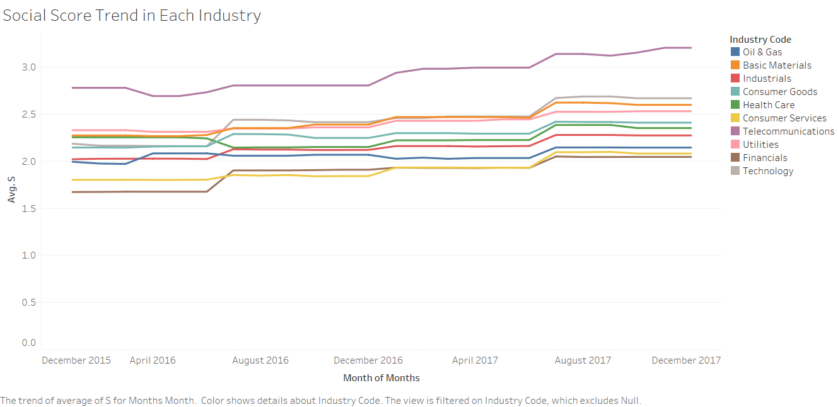

Figure 3.3.2.2 Social Score Trend in Each Industry

The three trend lines illustrate that social and governance scores have stable increase; while environmental score fluctuate the most. Telecommunications industry had been the leading industry for social and governance score. Since late 2017, telecommunications industry is taking the lead in environment score as well.

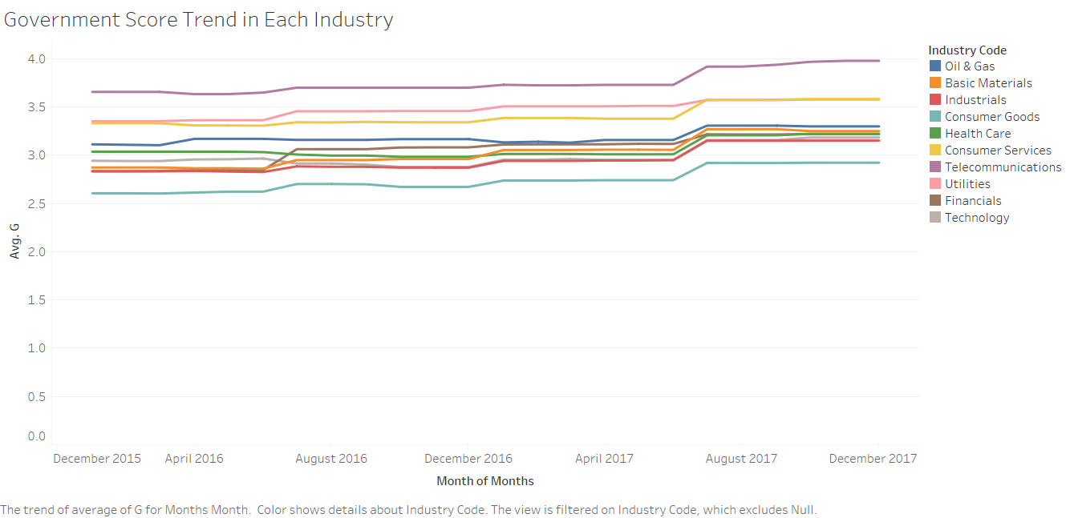

Figure 3.3.2.3 governance Score Trend in Each Industry

**3.4 Market Capitalization Study**

The data contains market capitalization and total market capitalization of all the companies. Since market capitalization is the value of total market value of all company’s outstanding shares, this analysis will be focused on market capitalization instead of total market capitalization.

Figure 3.4.1 demonstrates a comparison of market capitalization between companies with and without ESG score. The average market capitalization for companies with ESG score is drastically higher than the companies without ESG score. From the figure we could draw the conclusion that even though ESG score do not have association with company’s market capitalization numerically, company with ESG score will have higher market capitalization.

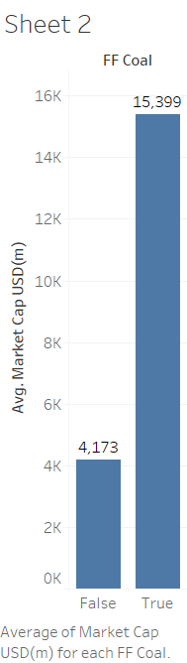

Figure 3.4.1 Market Capitalization and ESG score

Figure 3.4.2 shows the comparison of market capitalization between companies with green revenue and companies without. The result is similar to the previous comparison where companies that have green revenue are having higher market share.

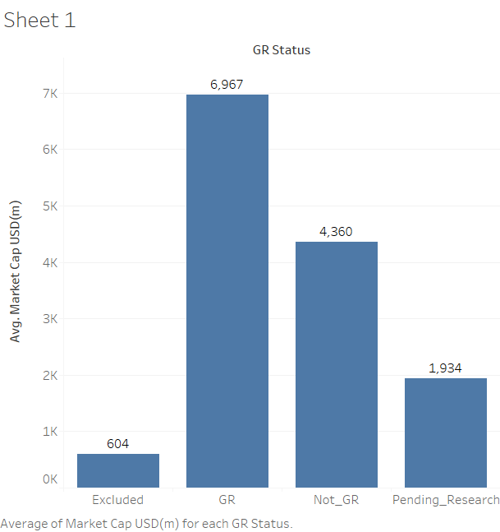

Figure 3.4.2 Bar Graph of Market Capitalization and Green Revenue

**3.5 Distribution of Average E, S and G Score Range**

The distribution analysis is generated from historical data (2016 to 2017). The number of records represents the number of companies in each respective range. Orange band represents number of company in 2016 and red band represents number of companies in 2017. Environment score reaches its peak in “1.0 to 1.2” range and none in “4.8 to 5” range. Social score reaches its peak around 2.2. Compared with the other two scores, governance score is skewed to the right, indicating that most companies’ scores are in the higher range. This finding proves that companies are giving more focus on the governance aspect, which include tax transparency, risk management, corporate governance, anti-corruption. The better performance in governance leads to the conclusion that companies are investing more on factors directly related to the internal management and financial performance, as opposed to external factors such as climate change and human rights & community.

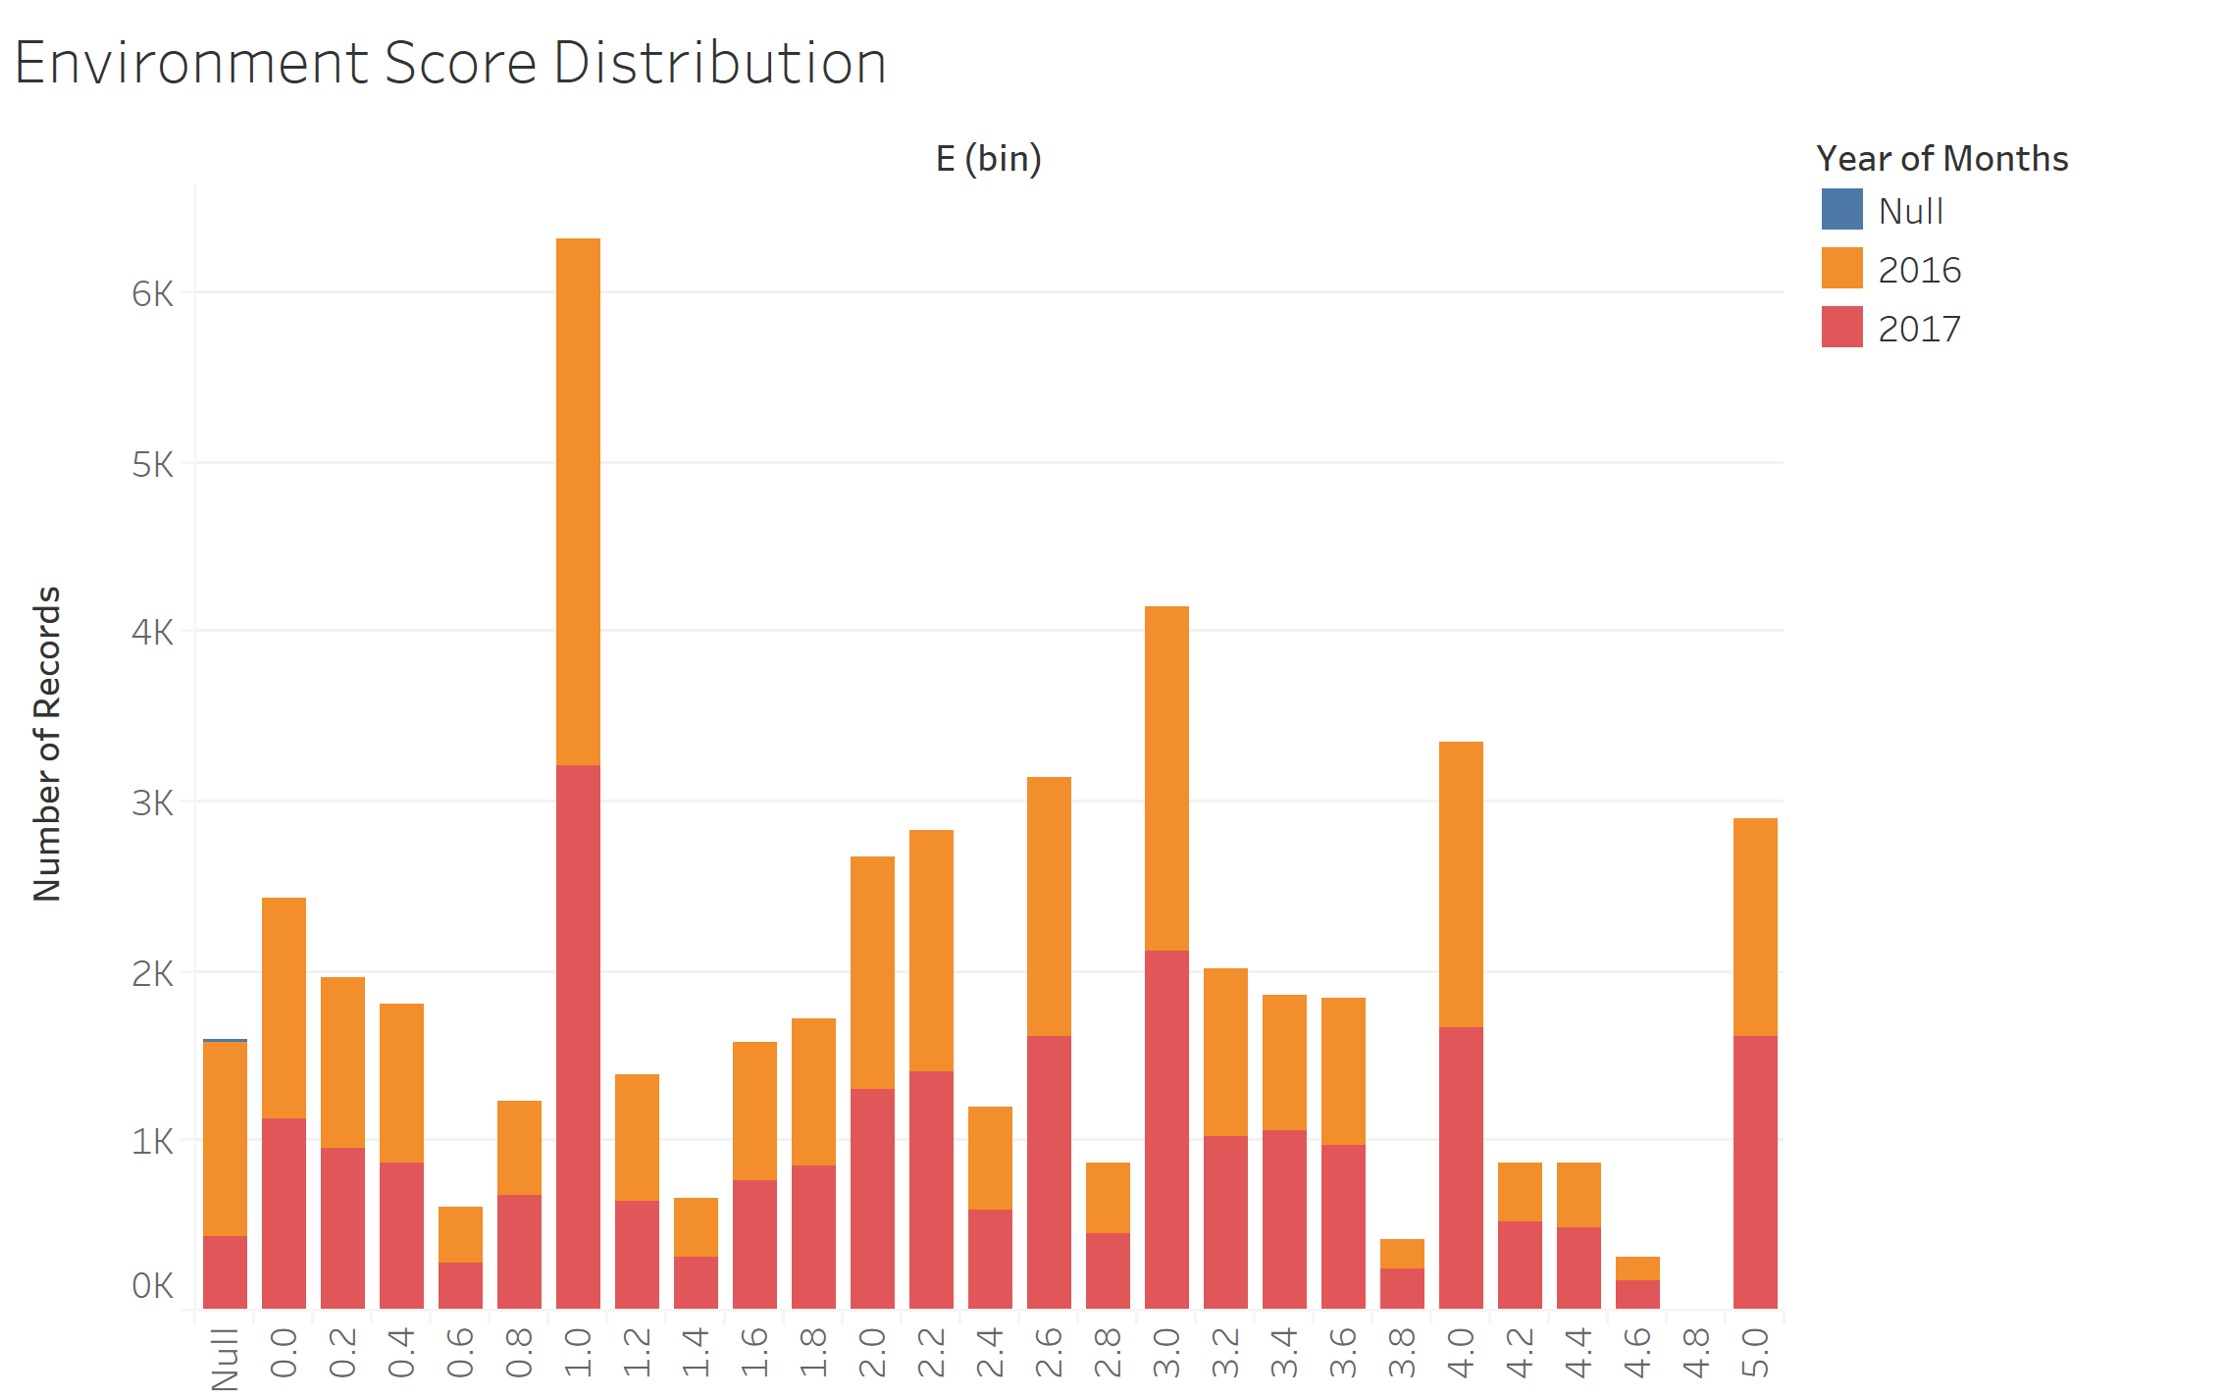

Figure 3.5.1 Environment Score Distribution

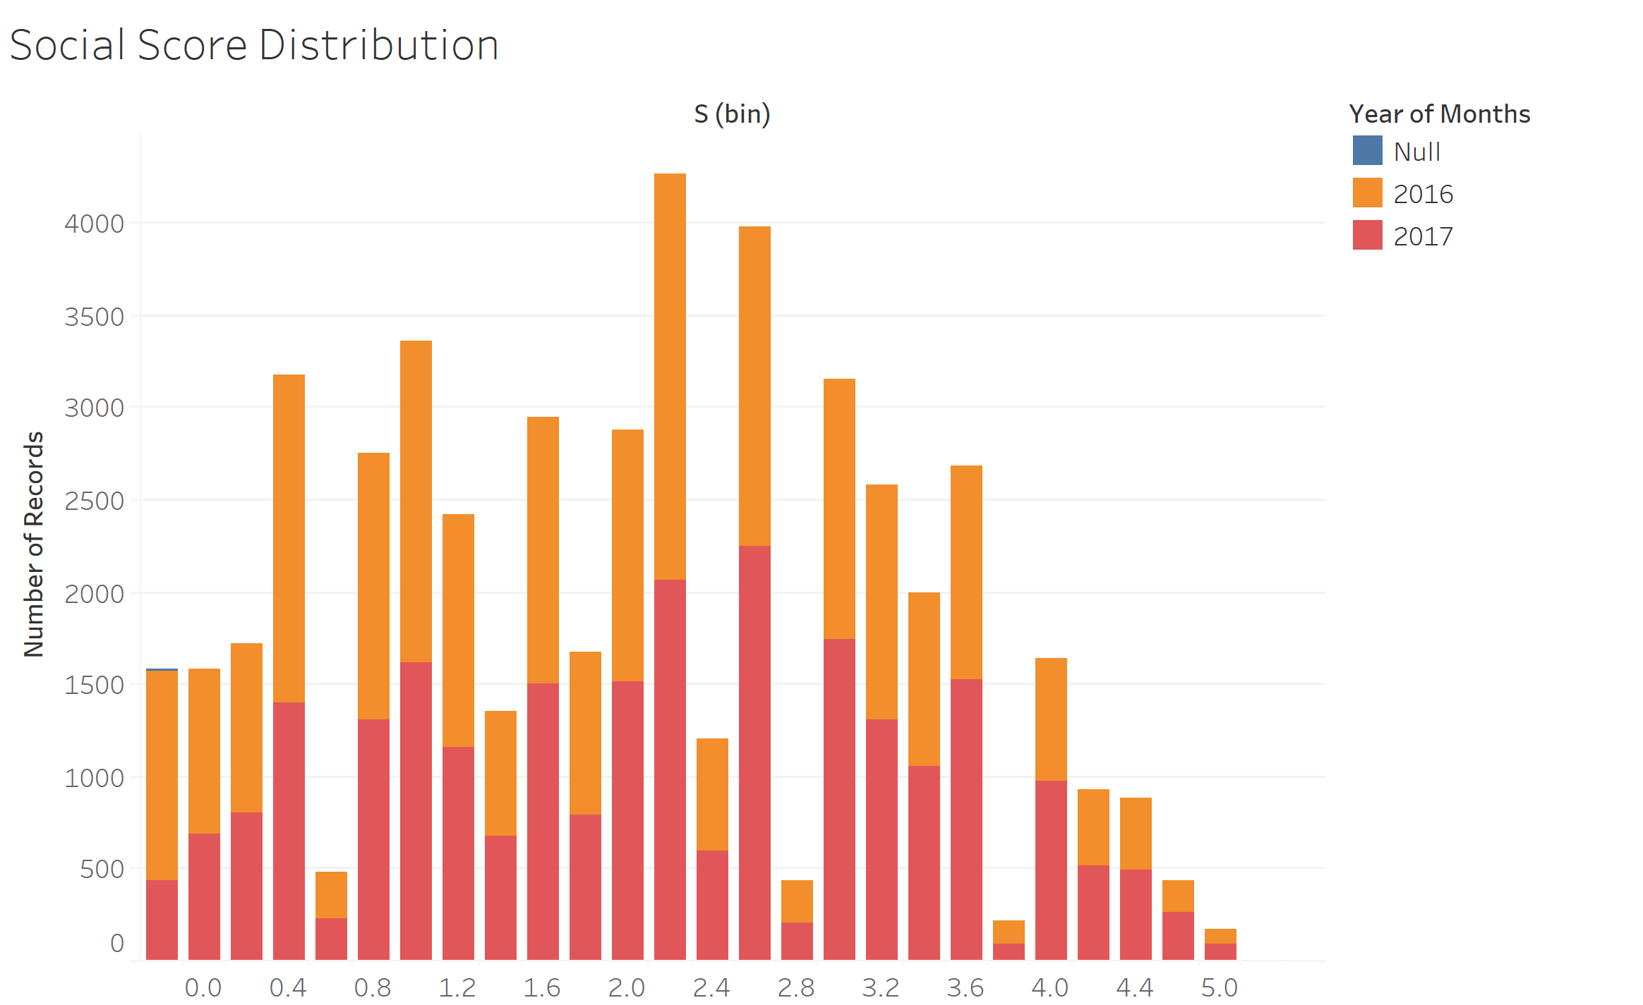

Figure 3.5.2 Social Score Distribution

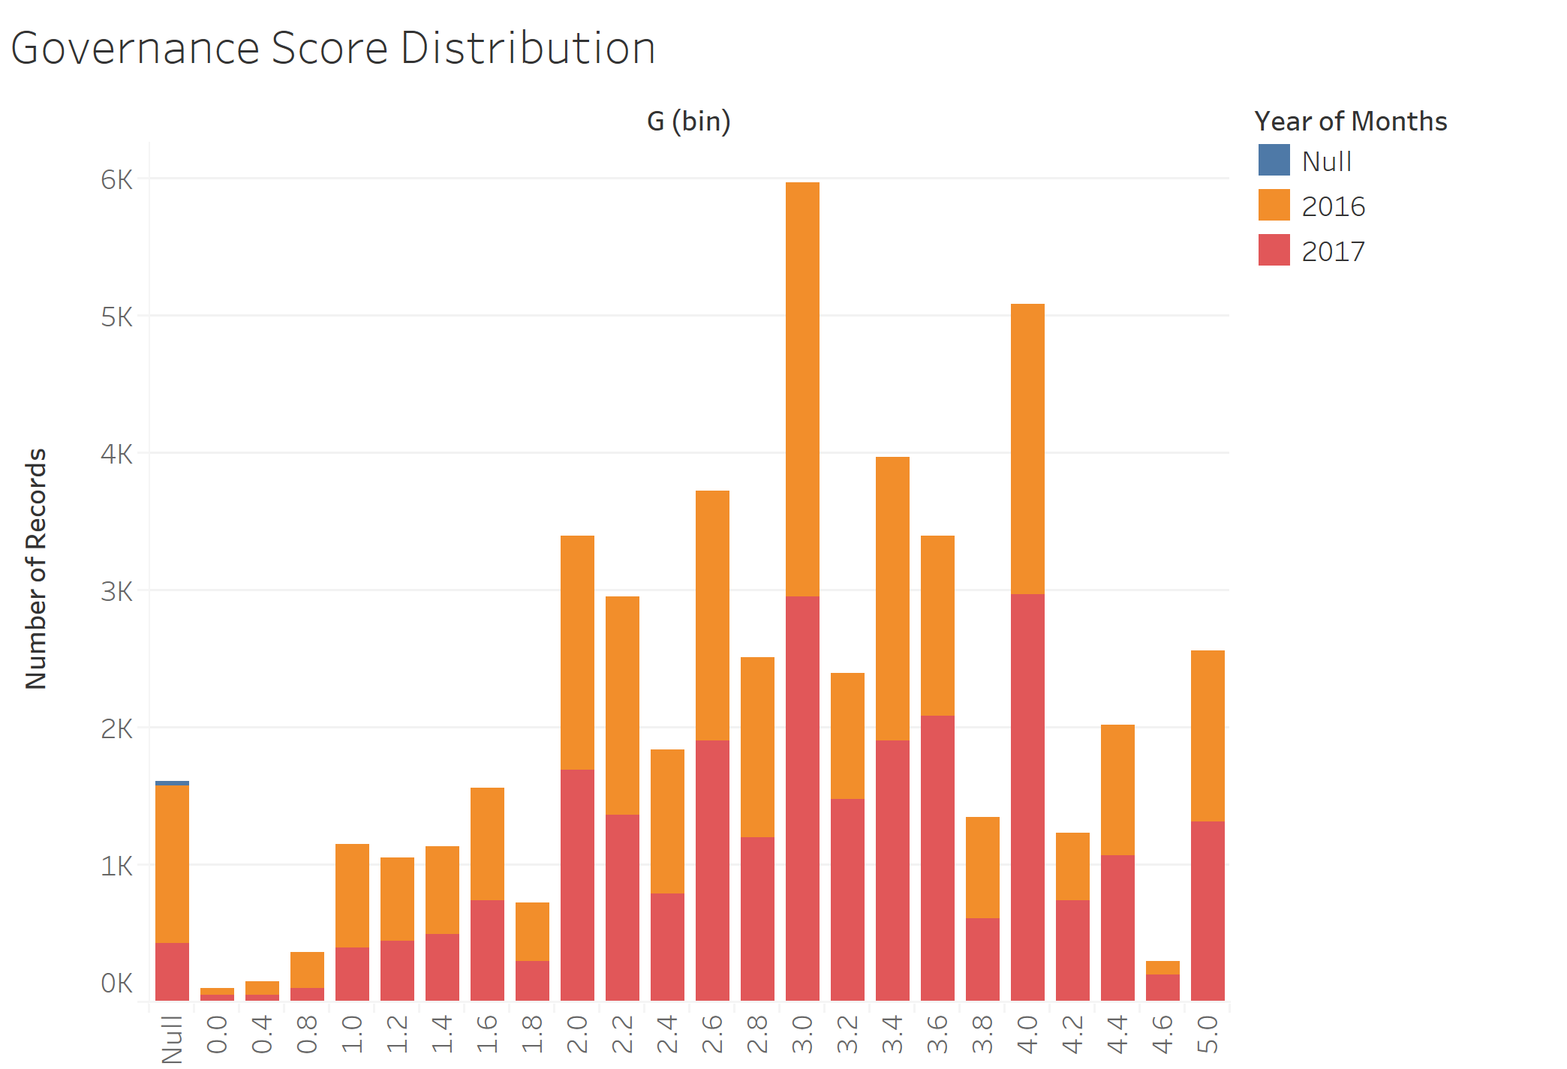

Figure 3.5.3 Governance Score Distribution

**4. Predictive Analysis**

Linear regression model is applied to predict company’s performance with E,S,G and ESG score. Company’s average E, S, G and ESG scores in 2017 are independent variables in this section, and average company performances in 2018 are dependent variables.

**4.1 Variable Selection**

|  |
| --- |
| **Dependent Variable:**  Tobin’s Q Ratio  Earnings Per Share  Profit Margin  Return on Asset  Return on Equity  Debt to Market Cap Ratio  Asset Turnover  Price to Sale Ratio  **Independent Variable:**  Environment Score  Social Score  Governance Score  ESG Score |
|
|
|

**4.2 Hypothesis**

H1: There is a positive relationship between ESG score and Tobin’s Q

H2: There is a positive relationship between ESG score and earning per share

H3: There is a positive relationship between ESG score and profit margin

H4: There is a positive relationship between ESG score and return on asset

H5: There is a positive relationship between ESG score and return on equity

H6: There is a positive relationship between ESG score and debt to market cap ratio

H7: There is a positive relationship between ESG score and asset turnover

H9: There is a positive relationship between ESG score and price to sale ratio

**4.3 Descriptive Statistics**

The following table is descriptive statistics of the 12 independent and dependent variables. This table allows us to gain insight of each variables before conduct regressions.

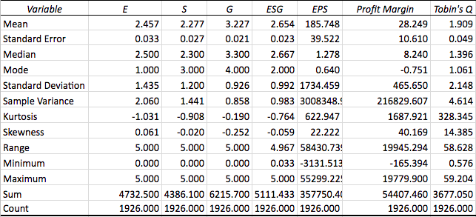

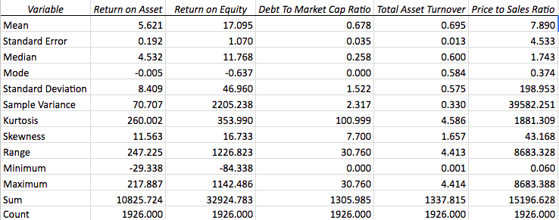

Figure 4.3.1 Table of Descriptive Statistics of Variables

**4.4 Correlation (Collinearity) Matrix**

The correlation matrix in figure 4.4.1 shows that environmental score has negative relationship with all the company performance variables except for Return on Equity and Debt to Market Cap Ratio. Social score has positive relationship with Return on Equity, Debt to Market Cap Ratio and Total Asset Turnover. Governance score has positive relationship with Tobin’s Q, Return on Asset, Return on Equity and Asset Turnover.

In conclusion, governance score is the most important score for investors to consider, since it has the highest absolute correlation with company performance variable. The following regression analysis will give a deeper understanding of relationship between the scores and company performance.

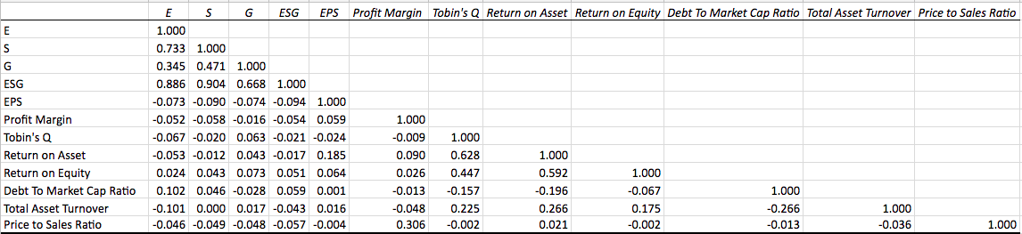

Figure 4.4.1 Correlation Matrix

**4.5 Regression**

To study the correlation between the 4 scores scores and 8 performance variables, 24 regression models are generated. Regression results are summarized in the tables below.

**4.5.1 Environmental Score**

The p-value of return on equity is greater than 0.05, which means return on equity is not significantly correlated with environment score. P-values of **EPS, Profit Margin, Tobin’s Q, Return on Asset, Debt to Market Cap Ratio, Total Asset Turnover, and Price to Sales Ratio** are smaller than 0.05. Therefore, these variables are significantly correlated with environment score. However, the coefficients of EPS, Profit Margin, Tobin’s Q, Return on Asset, Total Asset Turnover, and Price to Sales Ratio are negative, which proves negative correlations between these variables and environment score. Debt to Market Cap Ratio has positive correlation with environment score. This finding proves that money invested in Environment brings unwanted financial performance across all the ratios.

|  |  |  |  |  |  |
| --- | --- | --- | --- | --- | --- |
| Variable | Intercept | Coefficient | P-value | R Square | Adjusted R Square |
| **EPS** | 2.4683 | -5.99986E-05 | 0.0015 | 0.0053 | 0.0047 |
| **Profit Margin** | 2.4617 | -0.0002 | 0.0213 | 0.0028 | 0.0022 |
| **Tobin's Q** | 2.5425 | -0.0447 | 0.0033 | 0.0045 | 0.0040 |
| **Return on Asset** | 2.5080 | -0.009 | 0.0201 | 0.0028 | 0.0023 |
| Return on Equity | 2.4448 | 0.0007 | *0.2982* | 0.0006 | 4.30687E-05 |
| **Debt To Market Cap Ratio** | 2.3917 | 0.0965 | 6.74597E-06 | 0.0105 | 0.0099 |
| **Total Asset Turnover** | 2.6319 | -0.2516 | 9.49457E-06 | 0.0101 | 0.0096 |
| **Price to Sales Ratio** | 2.4598 | -0.0003 | 0.0437 | 0.0021 | 0.0016 |

Figure 4.5.1 Regression Matrix of Environment Score

**4.5.2 Social Score**

The p-values of Tobin’s Q, Return on Asset, Debt to Market Cap Ratio, Total Asset Turnover, Return on Equity are greater than 0.05, which means these variables are not significantly correlated with environment score. P-values of **EPS, Profit Margin, and Price to Sales Ratio** are smaller than 0.05. Therefore, these variables are significantly correlated with environment score. However, the coefficients of all three significant scores are negative, which means there are negative correlations between these variables and social score.

|  |  |  |  |  |  |
| --- | --- | --- | --- | --- | --- |
| Variable | Intercept | Coefficient | P-value | R Square | Adjusted R Square |
| **EPS** | 2.2889 | -0.000062 | 0.0000747 | 0.0081 | 0.0076 |
| **Profit Margin** | 2.2815 | -0.00015 | 0.01141 | 0.0033 | 0.0028 |
| Tobin's Q | 2.2987 | -0.1121 | *0.3788* | 0.0004 | -0.00012 |
| Return on Asset | 2.2871 | -0.00176 | *0.58* | 0.00015 | -0.00037 |
| Return on Equity | 2.258 | 0.0011 | *0.06* | 0.0018 | 0.0013 |
| Debt to Market Cap Ratio | 2.252 | 0.0366 | *0.4042* | 0.0022 | 0.0016 |
| Total Asset Turnover | 2.2766 | 0.001 | *0.9829* | 0.00000024 | -0.00052 |
| **Price to Sales Ratio** | 2.2796 | -0.00029 | 0.033 | 0.002 | 0.0018 |

Figure 4.5.2 Social Score Regression Matrix

**4.5.3 Governance Score**

The p-values of Profit Margin, Return on Asset, Debt to Market Cap Ratio, and Total Asset Turnover are greater than 0.05, which means these variables are not significantly correlated with environment score. P-values of **EPS, Tobin’s Q, Return on Equity and Price to Sales Ratio** are smaller than 0.05. Therefore, these variables are significantly correlated with environment score. The coefficients of the 4 financial ratios are all positive, which means there are positive correlations between these variables and environment score. Governance has the most positive correlations with company performances. The potential theory from this finding is that more resource invested in governance of a company, more likely the company’s performance will improve.

|  |  |  |  |  |  |
| --- | --- | --- | --- | --- | --- |
| Variable | Intercept | Coefficient | P-value | R Square | Adjusted R Square |
| **EPS** | 3.234 | -0.00004 | 0.00114 | 0.0055 | 0.00497 |
| Profit Margin | 3.2281 | -0.000032 | *0.477* | 0.000262 | -0.00026 |
| **Tobin's Q** | 3.175 | 0.0273 | 0.0054 | 0.004 | 0.0035 |
| Return on Asset | 3.2 | 0.004753 | *0.058* | 0.0019 | 0.0013 |
| **Return on Equity** | 3.2026 | 0.001441 | 0.001337 | 0.005336 | 0.0048 |
| Debt To Market Cap Ratio | 3.2387 | -0.017 | *0.222* | 0.00077 | 0.000255 |
| Total Asset Turnover | 3.20845 | 0.027 | *0.4612* | 0.000282 | -0.00024 |
| **Price to Sales Ratio** | 3.229 | -0.00022 | 0.037 | 0.002257 | 0.001739 |

Figure 4.5.3 Governance Score Regression Matrix

**5. Conclusion**

Our country level study shows that countries in northern and eastern Europe are having higher average ESG score whereas their number of companies with green revenues are less than the United States and China. The industry level study reveals the fact that over 50% of the companies are in industrials, financials and consumer services industry. Telecommunications, though representing only 2.4% of the market in this study, perform best in ESG score. Each industry shows different performance in each of ESG scores. Over the course of 2 years, fortunately, E, S and G scores in each industry had grown, meaning that companies are stressing the importance of social responsibility and shareholders’ well-being.

From predictive study, we found negative correlation between EPS, Profit Margin, Tobin’s Q, Return on Asset, Total Asset Turnover, and Price to Sales Ratio and positive correlation with debt to market cap ratio. Therefore, investors should look for worse Environment score if they prefer better financial performance. Social score has negative correlation with EPS, Profit Margin, and Price to Sales Ratio. Same as environment investment, social investment doesn’t generate good outcome for companies as well. Nevertheless, governance score shows positive relationship with EPS, Tobin’s Q, Return on Equity and Price to Sales Ratio. A positive governance score can be used for predicting positive performances. One possible explanation for this finding is that environment and social investment can be reflected externally factors and governance can be reflected internally. To build optimized investment portfolio, investors can seek companies with lower E and S score but higher G score.